**SOFTWARE TESTING USING SELENIUM**

**CIA-1**

**QUESTION 1:**

//QUESTION-1

**package** com.Test.CIA;

**import** org.openqa.selenium.By;

**import** org.openqa.selenium.WebDriver;

**import** org.openqa.selenium.chrome.ChromeDriver;

**import** org.openqa.selenium.chrome.ChromeOptions;

**import** io.github.bonigarcia.wdm.WebDriverManager;

**public** **class** Q_1test {

**public** **static** **void** main(String args[]) **throws** InterruptedException {

ChromeOptions co=**new** ChromeOptions();

co.addArguments("--remote-allow-origins=*");

WebDriverManager.*chromedriver*().setup();

WebDriver driver=**new** ChromeDriver(co);

driver.get("https://www.amazon.in/?&ext_vrnc=hi&tag=googhydrabk1-21&ref=pd_sl_7hz2t19t5c_e&adgrpid=58355126069&hvpone=&hvptwo=&hvadid=486458706470&hvpos=&hvnetw=g&hvrand=4911771880134568455&hvqmt=e&hvdev=c&hvdvcmdl=&hvlocint=&hvlocphy=9148884&hvtargid=kwd-10573980&hydadcr=14453_2154373");

driver.manage().window().maximize();

String currTitle=driver.getTitle();

String expTitle="Online Shopping site in India: Shop Online for Mobiles, Books, Watches, Shoes and More - Amazon.in";

**if**(currTitle.equals(expTitle)) {

System.***out***.println("Title is matched");

}

**else** {

System.***out***.println("Title is not matched");

}

driver.findElement(By.*xpath*("//*[@id=\"nav-link-accountList\"]")).click();

driver.findElement(By.*xpath*("//*[@id=\"ap_email\"]")).sendKeys("9944121514");

driver.findElement(By.*xpath*("//*[@id=\"continue\"]")).click();

driver.findElement(By.*xpath*("//*[@id=\"ap_password\"]")).sendKeys("sahana2003");

driver.findElement(By.*xpath*("//*[@id=\"signInSubmit\"]")).click();

//Add to Cart

driver.get("https://www.amazon.in/Graphic-Leather-Compact-Passport-Holder/dp/B07YDG8TXM/ref=sxin_25_slsr_d_i_fs4star_fa_cue_0_B07YDG8TXM?content-id=amzn1.sym.38b84696-ffe4-48a8-accc-c9001fc80941%3Aamzn1.sym.38b84696-ffe4-48a8-accc-c9001fc80941&cv_ct_cx=passport%2Bholder&keywords=passport%2Bholder&pd_rd_i=B07YDG8TXM&pd_rd_r=1957b543-3d7e-4a97-81fd-8381365d3ffb&pd_rd_w=t7d1i&pd_rd_wg=y6soy&pf_rd_p=38b84696-ffe4-48a8-accc-c9001fc80941&pf_rd_r=5RMJETD8SSSYM11TZ66N&qid=1681316027&sbo=RZvfv%2F%2FHxDF%2BO5021pAnSA%3D%3D&sprefix=passport%2B%2Caps%2C280&sr=1-1-41e0d225-3819-4755-898e-7f0f48633b47&th=1");

Thread.*sleep*(3000);

driver.findElement(By.*xpath*("//*[@id=\"add-to-cart-button\"]")).click();

String CurrentText=driver.findElement(By.*xpath*("//*[@id=\"NATC_SMART_WAGON_CONF_MSG_SUCCESS\"]/span")).getText();

String ExpText="Added to Cart";

**if**(CurrentText.equals(ExpText)) {

System.***out***.println("Added to Cart Sucessfully");

}

**else** {

System.***out***.print("Not Added to Cart");

}

//removing Product

driver.get("https://www.amazon.in/gp/cart/view.html?ref_=sw_gtc");

driver.findElement(By.*xpath*("//*[@id=\"a-autoid-0-announce\"]")).click();

driver.findElement(By.*xpath*("//*[@id=\"quantity_0\"]")).click();

String CurrText=driver.findElement(By.*xpath*("//*[@id=\"sc-active-cart\"]/div/div[1]/div/h1")).getText();

String expText="Shopping Cart";

**if**(CurrText.equals(expText)) {

System.***out***.println("Removed from the cart");

}

**else** {

System.***out***.println("Not Removed from the cart");

}

//Updating the Quantity

driver.navigate().to("https://www.amazon.in/Graphic-Leather-Compact-Passport-Holder/dp/B07YDG8TXM/ref=sxin_25_slsr_d_i_fs4star_fa_cue_0_B07YDG8TXM?content-id=amzn1.sym.38b84696-ffe4-48a8-accc-c9001fc80941%3Aamzn1.sym.38b84696-ffe4-48a8-accc-c9001fc80941&cv_ct_cx=passport%2Bholder&keywords=passport%2Bholder&pd_rd_i=B07YDG8TXM&pd_rd_r=1957b543-3d7e-4a97-81fd-8381365d3ffb&pd_rd_w=t7d1i&pd_rd_wg=y6soy&pf_rd_p=38b84696-ffe4-48a8-accc-c9001fc80941&pf_rd_r=5RMJETD8SSSYM11TZ66N&qid=1681316027&sbo=RZvfv%2F%2FHxDF%2BO5021pAnSA%3D%3D&sprefix=passport%2B%2Caps%2C280&sr=1-1-41e0d225-3819-4755-898e-7f0f48633b47&th=1");

driver.findElement(By.*xpath*("//*[@id=\"add-to-cart-button\"]")).click();

driver.findElement(By.*xpath*("//*[@id=\"sw-gtc\"]/span/a")).click();

driver.findElement(By.*xpath*("//*[@id=\"a-autoid-0-announce\"]")).click();

driver.findElement(By.*xpath*("//*[@id=\"quantity_5\"]")).click();

//Cost

driver.findElement(By.*xpath*("//*[@id=\"sc-buy-box-ptc-button\"]/span/input")).click();

String Cost=driver.findElement(By.*xpath*("//*[@id=\"subtotals-marketplace-table\"]/tbody/tr[4]/td[2]")).getText();

System.***out***.println("Total Cost "+Cost);

}

}

**OUTPUT:**

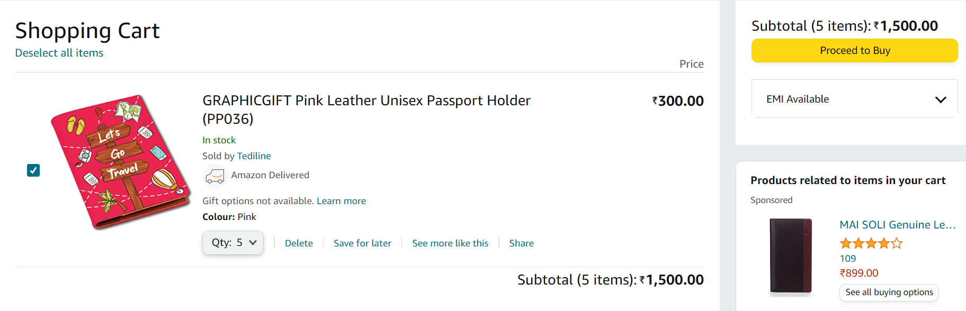

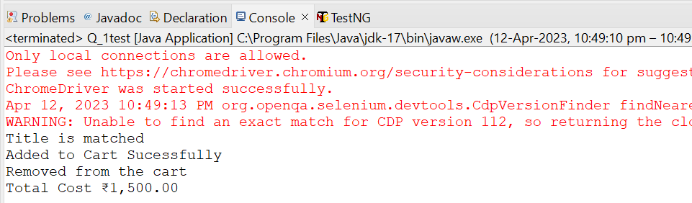

**QUESTION 2:**

//Question-2

package com.Test.CIA;

import java.util.List;

import org.openqa.selenium.By;

import org.openqa.selenium.WebDriver;

import org.openqa.selenium.WebElement;

import org.openqa.selenium.chrome.ChromeDriver;

import org.openqa.selenium.chrome.ChromeOptions;

import io.github.bonigarcia.wdm.WebDriverManager;

public class TestQ2 {

public static void main(String args[]) throws InterruptedException {

ChromeOptions co=new ChromeOptions();

co.addArguments("--remote-allow-origins=*");

WebDriverManager.chromedriver().setup();

WebDriver driver=new ChromeDriver(co);

driver.get("https://www.amazon.in/");

driver.manage().window().maximize();

String CurrentTitle=driver.getTitle();

System.out.println(CurrentTitle);

String ExpectedTitle="Online Shopping site in India: Shop Online for Mobiles, Books, Watches, Shoes and More - Amazon.in";

if(CurrentTitle.equals(ExpectedTitle))

{

System.out.println("Title Matched.");

}

else

{

System.out.println("Title not Matched");

}

Thread.sleep(3000);

driver.findElement(By.xpath("//*[@id=\"twotabsearchtextbox\"]")).sendKeys("Backpack");

driver.findElement(By.xpath("/html/body/div[1]/header/div/div[1]/div[2]/div/form/div[3]/div/span/input")).click();

List<WebElement> li=driver.findElements(By.className("s-line-clamp-1"));

for(WebElement link:li) {

System.out.println(link.getText());

}

driver.findElement(By.xpath("//*[@id=\"p_89/Skybags\"]/span/a/div/label/i")).click();

driver.findElement(By.xpath("//*[@id=\"p_89/Safari\"]/span/a/div/label/i")).click();

}

}

**OUTPUT:**

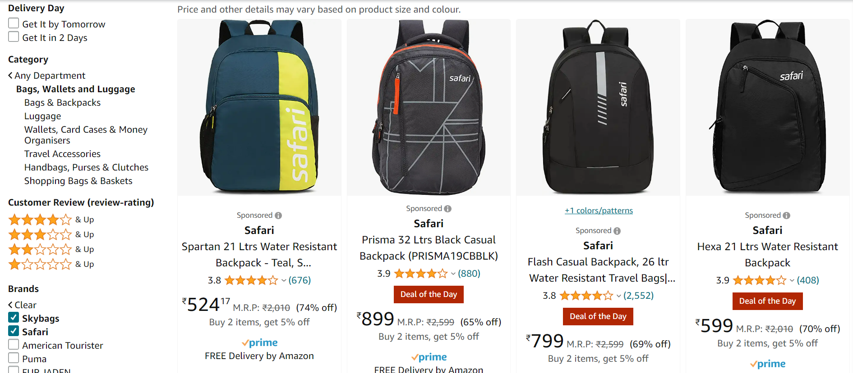

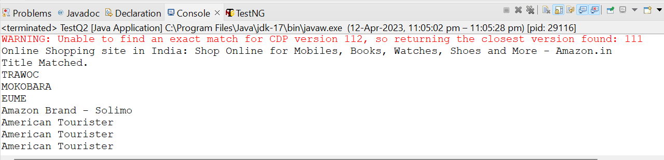

**QUESTION 3:**

//Question-3

**package** com.Test.CIA;

**import** org.openqa.selenium.By;

**import** org.openqa.selenium.WebDriver;

**import** org.openqa.selenium.chrome.ChromeDriver;

**import** org.openqa.selenium.chrome.ChromeOptions;

**import** io.github.bonigarcia.wdm.WebDriverManager;

**public** **class** Q1test {

**public** **static** **void** main(String args[]) **throws** InterruptedException {

ChromeOptions co=**new** ChromeOptions();

co.addArguments("--remote-allow-origins=*");

WebDriverManager.*chromedriver*().setup();

WebDriver driver=**new** ChromeDriver(co);

driver.get("https://www.amazon.in/ap/signin?openid.pape.max_auth_age=900&openid.return_to=https%3A%2F%2Fwww.amazon.in%2Fgp%2Fyourstore%2Fhome%3Fpath%3D%252Fgp%252Fyourstore%252Fhome%26useRedirectOnSuccess%3D1%26signIn%3D1%26action%3Dsign-out%26ref_%3Dnav_AccountFlyout_signout&openid.assoc_handle=inflex&openid.mode=checkid_setup&openid.ns=http%3A%2F%2Fspecs.openid.net%2Fauth%2F2.0");

driver.manage().window().maximize();

String currTitle=driver.getTitle();

String expTitle="Amazon Sign In";

**if**(currTitle.equals(expTitle)) {

System.***out***.println("Title is matched");

}

**else** {

System.***out***.println("Title is not matched");

}

driver.findElement(By.*xpath*("//*[@id=\"ap_email\"]")).sendKeys("9944121514");

driver.findElement(By.*xpath*("//*[@id=\"continue\"]")).click();

driver.findElement(By.*xpath*("//*[@id=\"ap_password\"]")).sendKeys("sahana2003");

driver.findElement(By.*xpath*("//*[@id=\"signInSubmit\"]")).click();

driver.findElement(By.*xpath*("//*[@id=\"nav-link-accountList\"]")).click();

driver.findElement(By.*xpath*("//*[@id=\"a-page\"]/div[2]/div/div[2]/div[1]/a/div/div")).click();

String orders=driver.findElement(By.*xpath*("//*[@id=\"a-page\"]/section/div[1]/div[4]/form/label")).getText();

System.***out***.print(orders+" Amazon");

}

}

**OUTPUT:**

